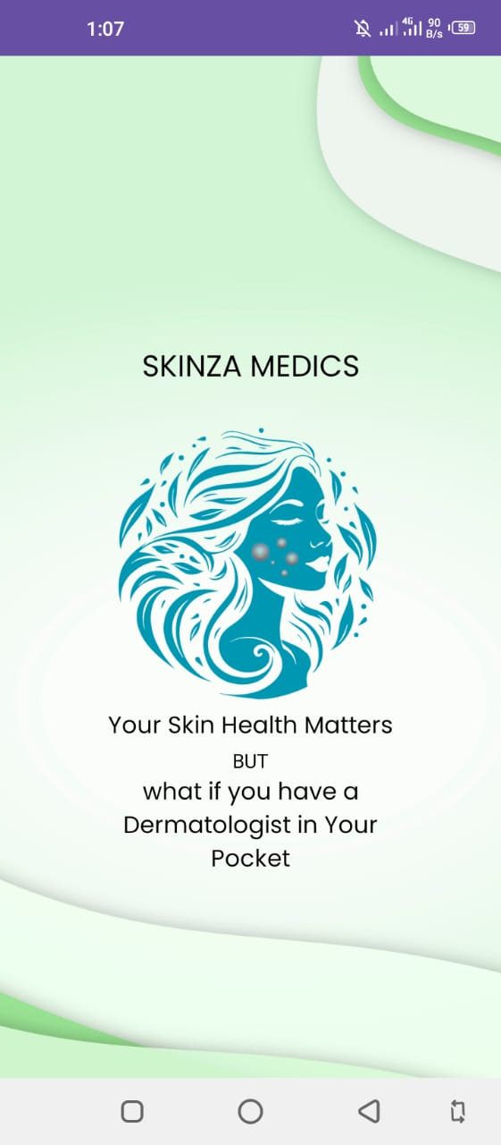**APP SCREENS:**

**Splash Screen:**

The first screen in our application is the splash screen which enhances brand recognition and provides a visually engaging loading period with a proper logo based on the skincare theme also with the appropriate tagline that states “Your skin health matters, But what if you have a Dermatologist in your pocket” while the app initializes resources, ensuring a smooth user experience. The timer on the splash screen is set to almost 3 seconds.

**Log In/Sign Up Screens:**

After the splash screen, the user will move to the login page to ensure secure user authentication, protect personal data, and provide personalized experiences based on user profiles. The user will enter their credentials. If the user is using the application for the first time, they will move to the sign-up page where they will enter their name, date of birth, email, and mobile number. There is also an option to read the terms and privacy policy before signing up. After signing up, the user will move to the main screen. Additionally, there is an option for Google authentication through Gmail.

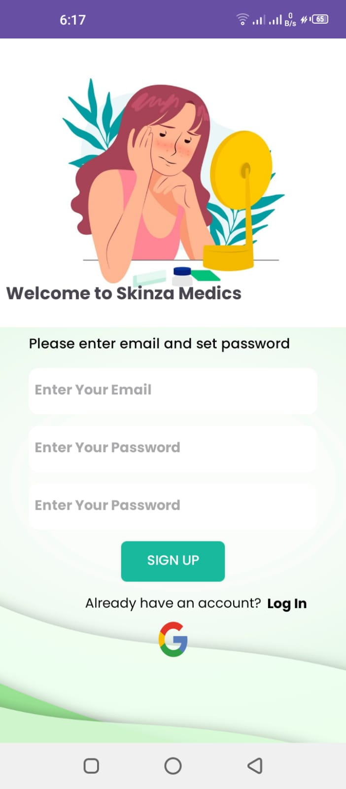 

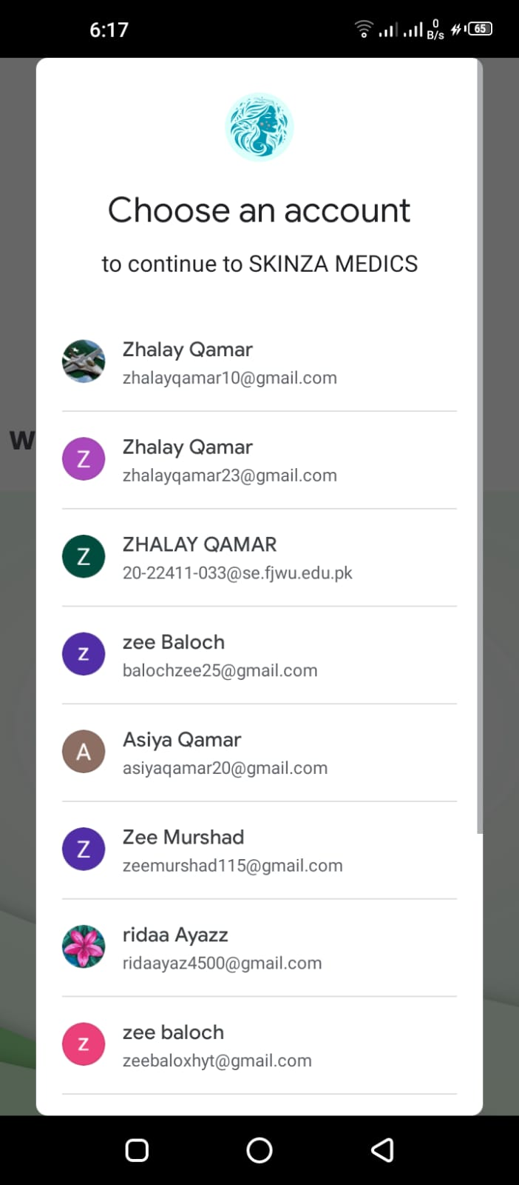 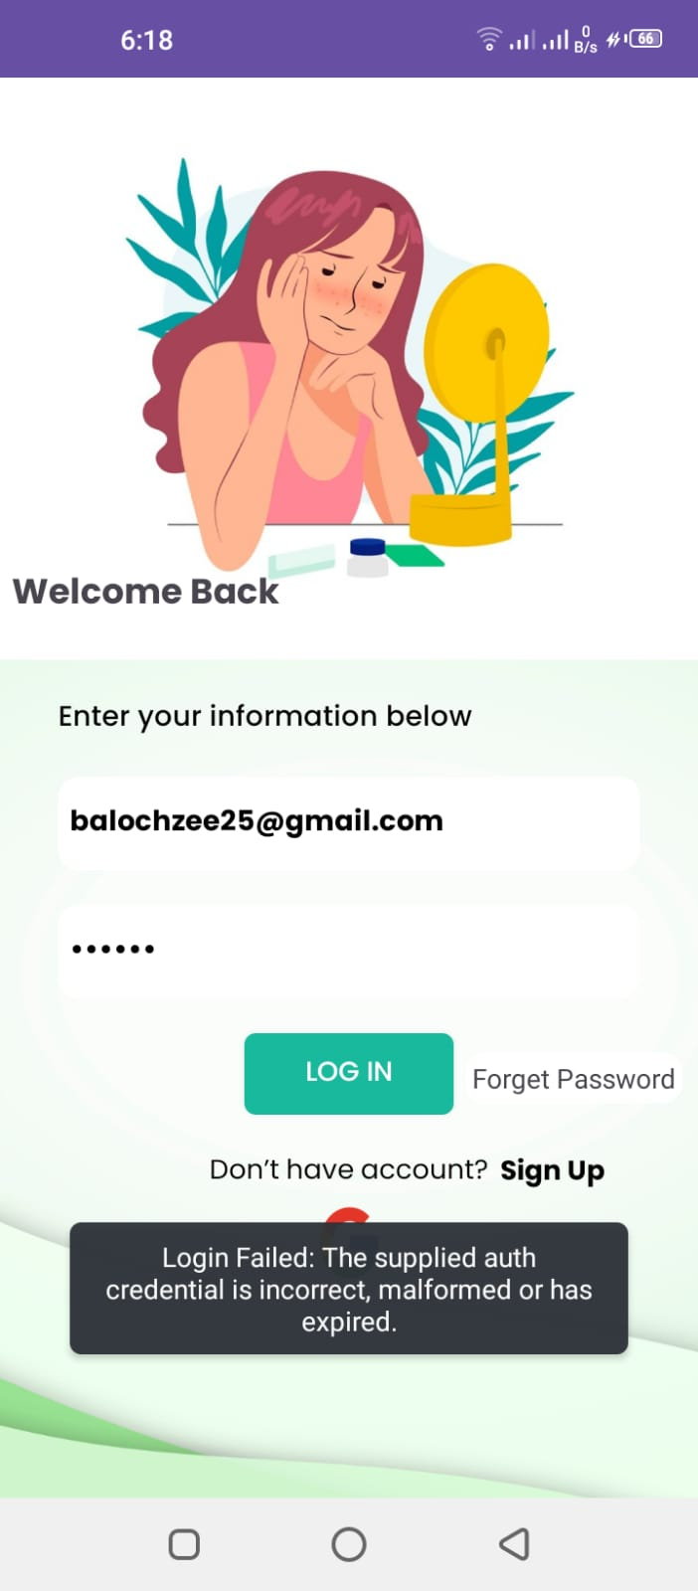

**MAIN SCREEN:**The user will move to the main page, which includes two main features of our application: diagnosing diseases and finding doctors in their preferred region. Additional options include the user's profile information, a list of favorite doctors, and a help menu to contact us on WhatsApp or Instagram. When the user clicks on the navbar, options such as update profile, helpline, favorites, settings, and logout will be available for easy access.  
  
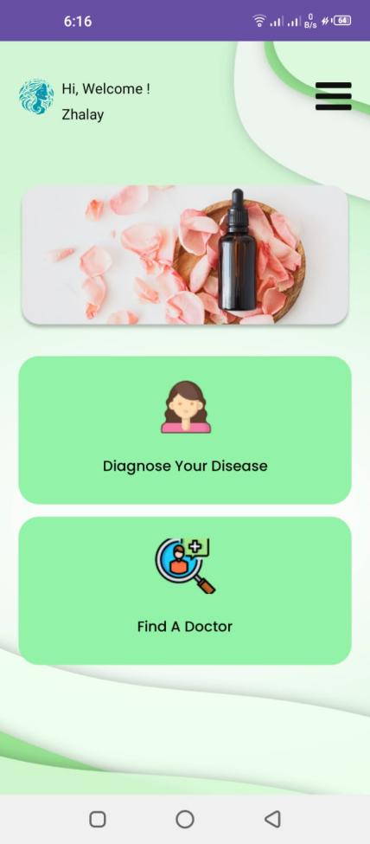 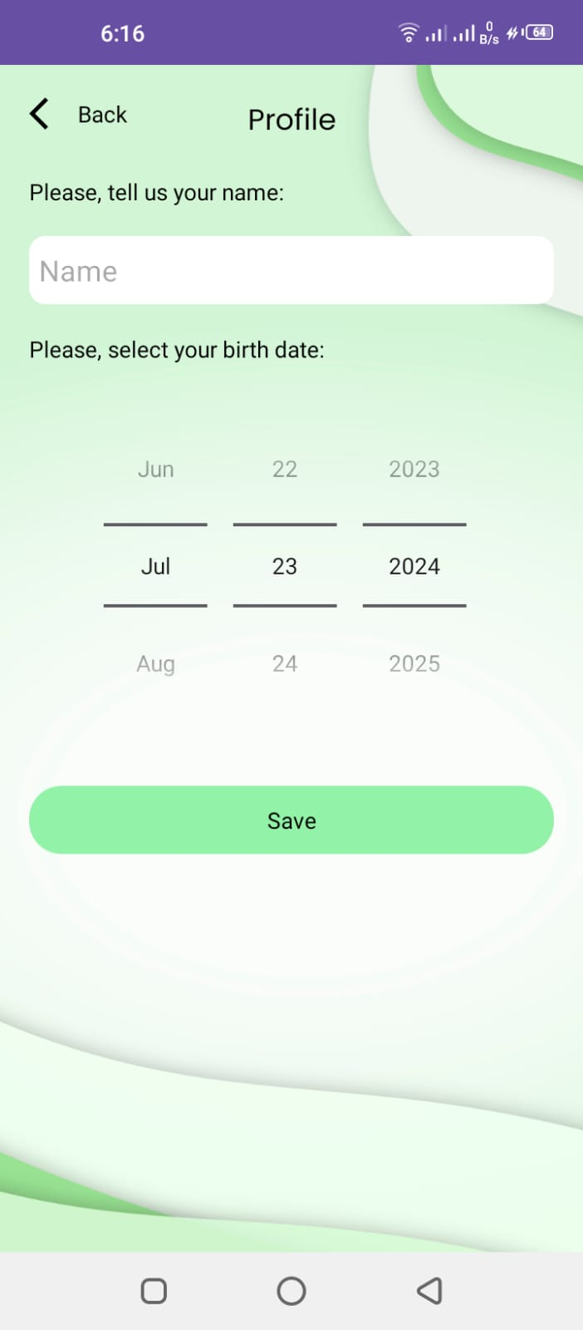

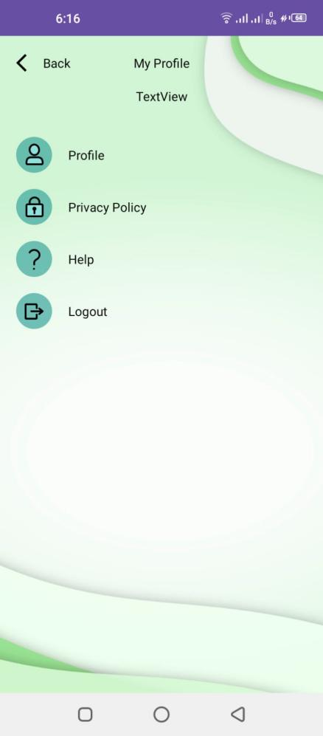 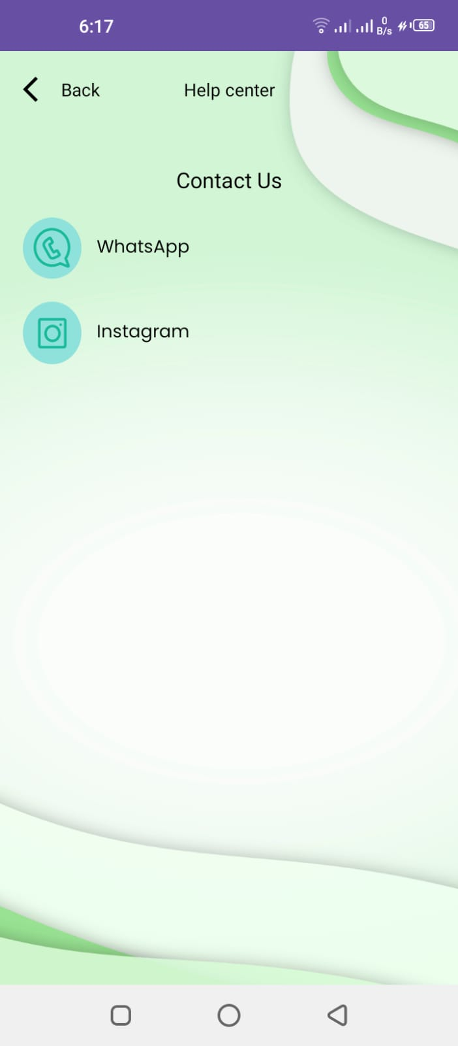

**DIGANOSE YOUR DISEASE:**

After choosing "Diagnose Your Disease," the user will move to the next screen to add a new case. By clicking on this option, the user will navigate to a screen where they need to upload at least one pictures of their infected areas from the gallery. Afterward, the user will be asked to answer multiple questions to help predict the correct disease.Now it will take time to load the model working on the backend to predict the disease of an infected area of the user and will also provide the self-care of that particular disease.

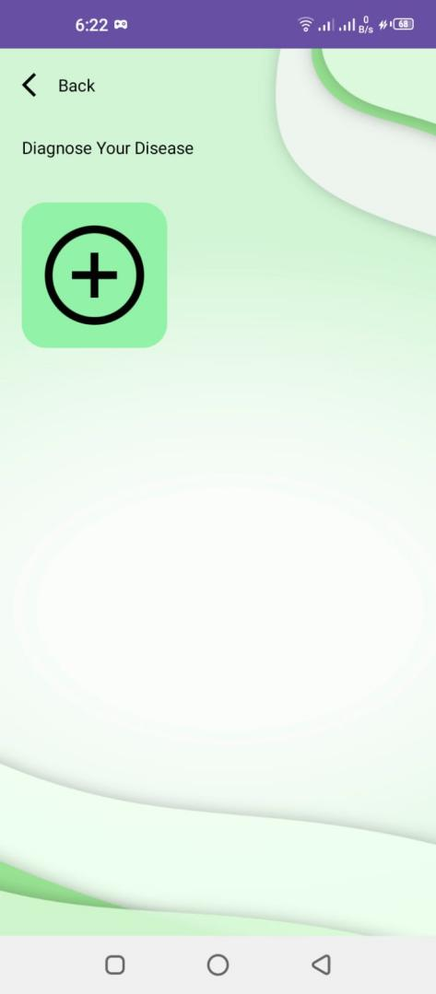 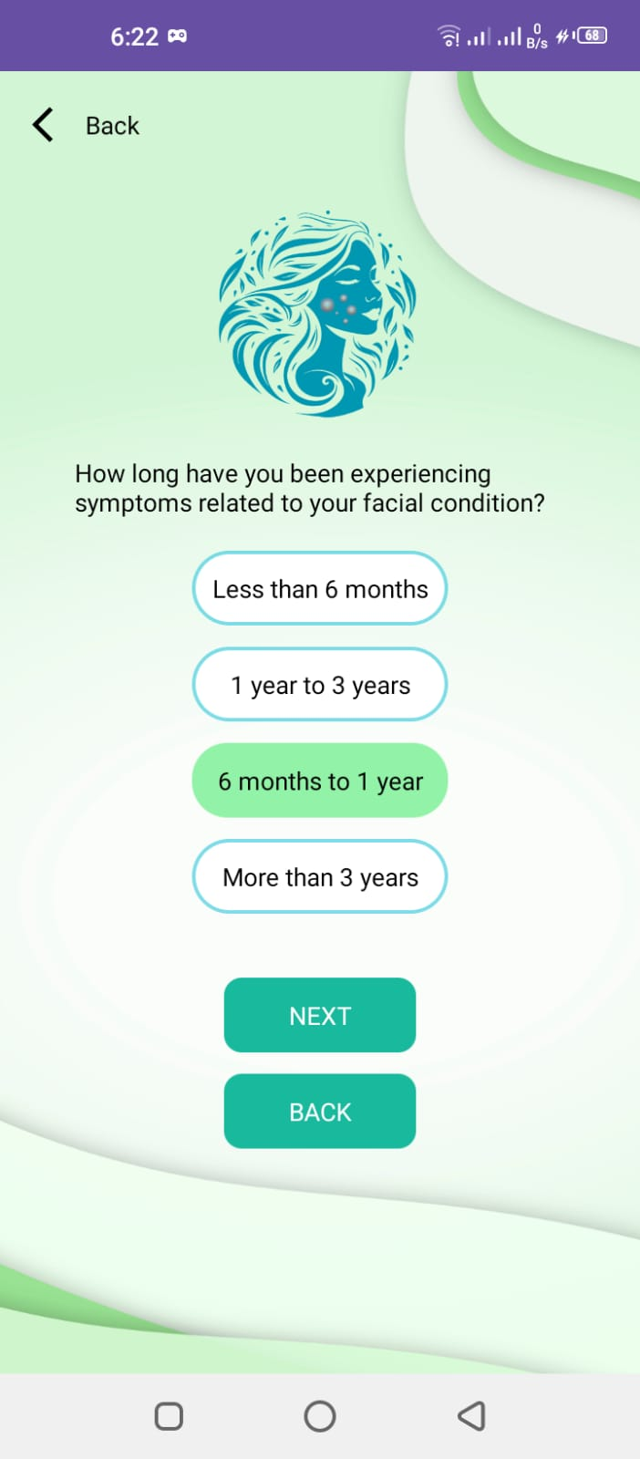

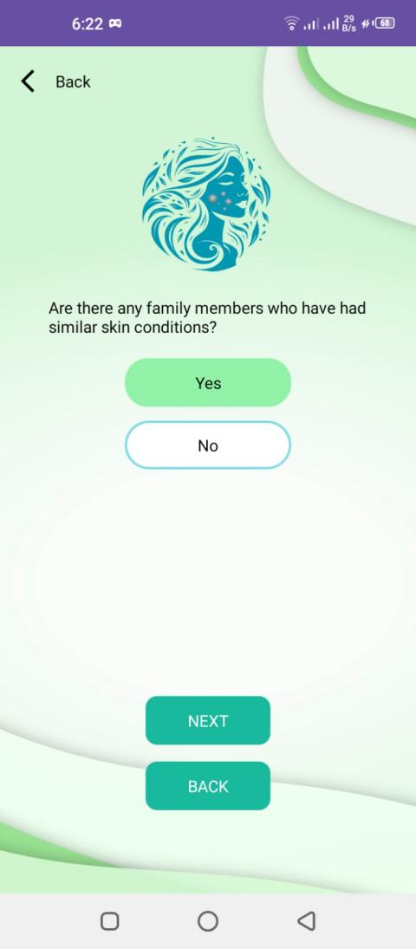 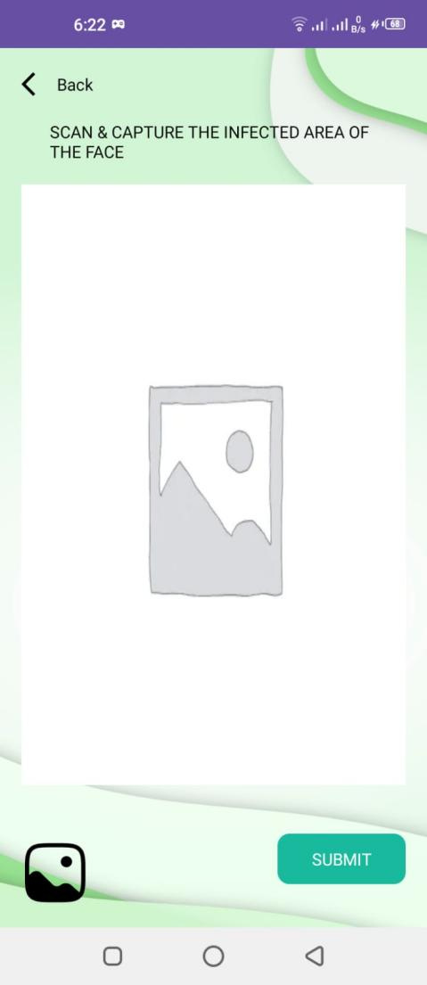

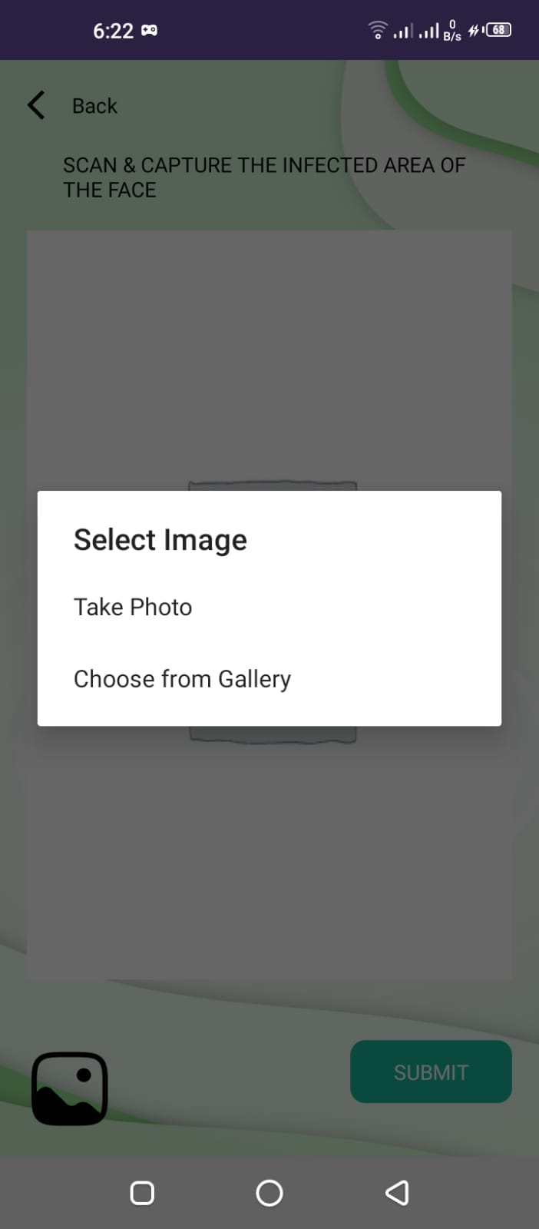 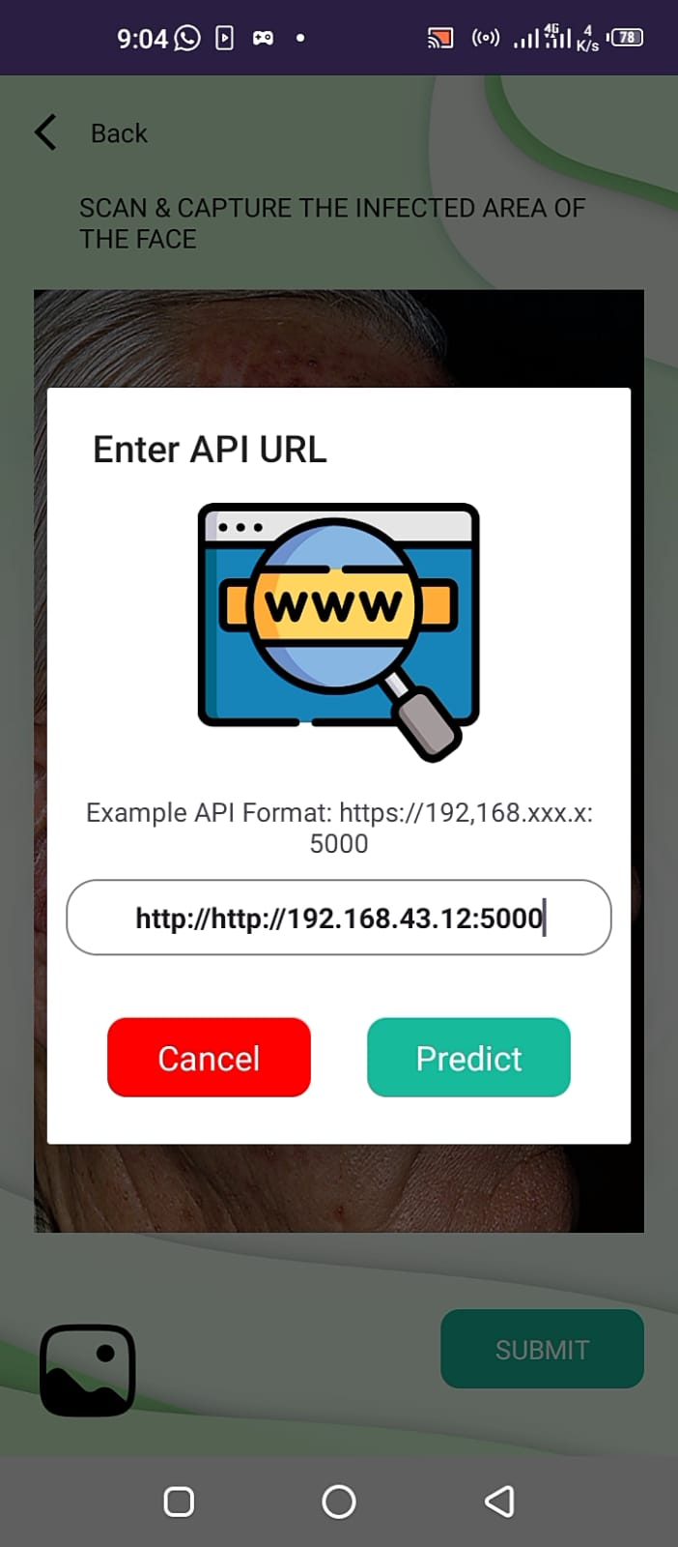

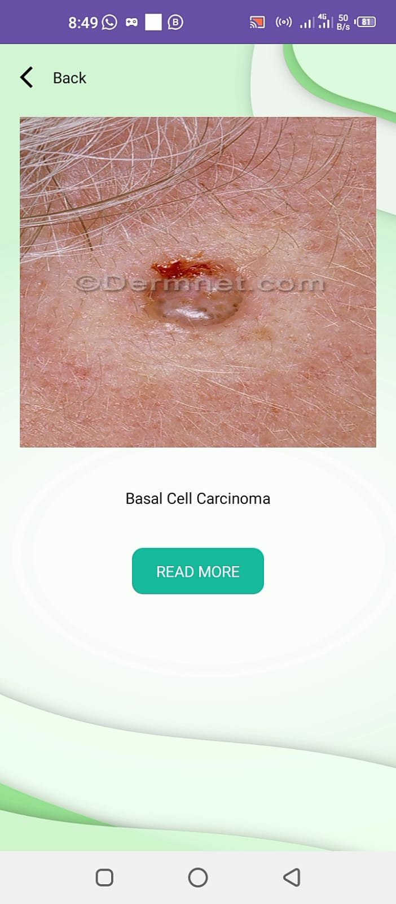 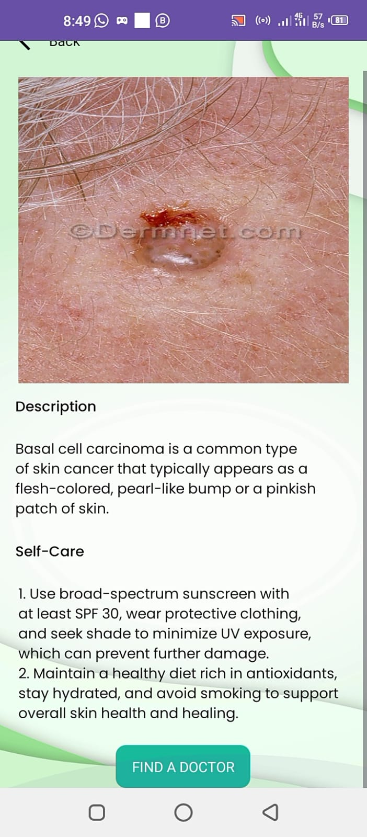

**DOCTORS ONBOARD:**

The page has two links: one from the main page after clicking on "Find a Doctor" and another after diagnosing a user's disease. This will display a list of recommended doctors who are on board. The user can easily open each doctor's profile one by one to check which suits them best in terms of time, location, and budget.

